**EXERCISE: SETTING UP JUNIT**

Scenario: You need to set up JUnit in your Java project to start writing unit tests.

Steps:

1. Create a new Java project in your IDE (e.g., IntelliJ IDEA, Eclipse).

2. Add JUnit dependency to your project.

If you are using Maven, add the following to your pom.xml:

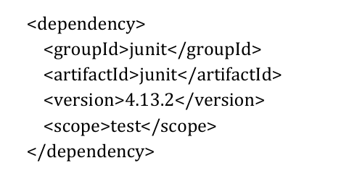

3. Create a new test class in your project.

**OUTPUT:**

